PLANNING
🚗 What is OBD-II?
OBD-II is a standardized system installed in most vehicles (1996 onwards) that monitors engine and other vital systems' performance. It provides real-time access to vehicle data and trouble codes (DTCs - Diagnostic Trouble Codes) that mechanics use for diagnosis.

Key Data You Can Extract from OBD-II:
- Engine RPM
- Vehicle speed
- Fuel system status
- Engine coolant temperature
- Intake air temperature
- Mass airflow rate (MAF)
- Throttle position
- DTC error codes (engine, transmission, emissions, etc.)
- Fuel consumption data
- Battery voltage
- Oxygen sensor readings

🔎 Problem Statement:
Vehicles often follow a fixed periodic maintenance schedule based on kilometers or time (e.g., every 10,000 km or 6 months). However:
- This doesn’t account for actual vehicle usage, driving habits, or component wear.
- Some parts may wear out earlier due to harsh conditions (frequent idling, heavy loads, overheating) leading to breakdowns or costly repairs.
- Others may be replaced too early, increasing unnecessary maintenance costs.
➔ Our Goal:
Build a system that uses real-time OBD-II data and predictive analytics to recommend optimal maintenance times—before failures, but only when truly needed.

🧠 Scope of the Project:
- Data Collection: Use an OBD-II Bluetooth/Wi-Fi dongle (e.g., ELM327) connected to a smartphone or Raspberry Pi.
- Target Maintenance Areas:
  - Engine performance (misfires, overheating)
  - Battery health (voltage drops)
  - Fuel efficiency degradation
  - Oil health (based on engine load and driving patterns)
  - Air-fuel ratio and emission system monitoring
- Deliverables:
  - A working data collection pipeline
  - Predictive maintenance model
  - Dashboard to visualize real-time vehicle health
  - Maintenance alerts/notifications

🛠 Detailed Components:
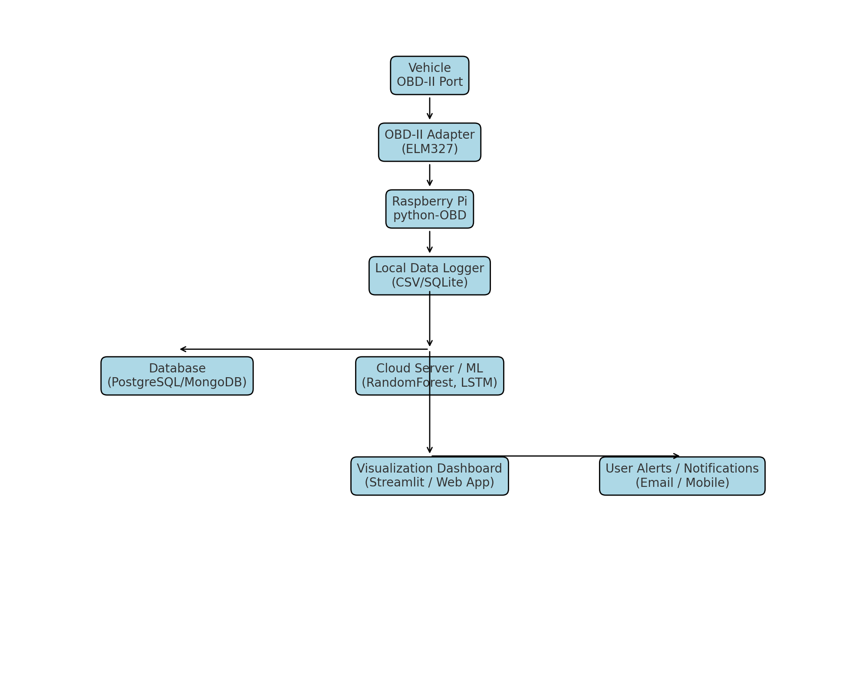
1. OBD-II Adapter (ELM327)
- Connects to your car’s OBD-II port
- Reads live vehicle data: RPM, speed, engine load, coolant temperature, DTCs, fuel efficiency
- Communicates with Raspberry Pi via Bluetooth or Wi-Fi

2. Raspberry Pi (Edge Device)
- Runs Python script with python-OBD library
- Pulls live data from the OBD-II adapter
- Optionally preprocesses or filters the data
- Stores locally (for offline use) or pushes to the cloud
- Bonus: You can add a GPS module here for location-based insights

3. Cloud Server / Local ML Model
- Database (PostgreSQL / MongoDB / AWS S3) stores historical data
- Machine Learning Models:
  - Random Forest / XGBoost: Predict maintenance needs
  - LSTM / GRU: Predict performance degradation over time
  - Anomaly Detection (Isolation Forest): Spot abnormal behavior
- Scheduled training with new data to improve model accuracy

4. Visualization Dashboard (Web / Mobile / Streamlit) – Not on deployment IGNORE
- Displays:
  - Real-time vehicle health status
  - Predictive maintenance alerts (e.g., “Air filter likely needs changing in 2 weeks”)
  - Visual graphs (engine temp over time, RPM spikes)
- Could send email/SMS/Push notifications to the user
- Optional: Integrate Google Maps API for route impact analysis

🛠 Detailed Approach:
Phase 1: System Setup & Data Collection
- Procure OBD-II Adapter: ELM327 Bluetooth/Wi-Fi module (~$20-30).
- Device Connection: Connect adapter to the vehicle’s OBD-II port and stream data to:
  - Mobile app (Torque Pro, Car Scanner) OR
  - Raspberry Pi / Laptop (Python with python-OBD library)
- Data Logging:
  - Store real-time data into CSV / database
  - Collect data over several weeks of driving under varied conditions
- Dataset Preparation:
  - Feature extraction: speed, RPM, coolant temp, throttle, engine load
  - DTCs and frequency of occurrence

Phase 2: Exploratory Data Analysis (EDA)
- Analyze how parameters like coolant temp, fuel efficiency, or RPM spikes relate to known maintenance issues.
- Identify patterns indicating wear/tear or degrading performance.

Phase 3: Predictive Model Development
- Supervised Learning: If historical maintenance logs are available:
  - Train a Random Forest / XGBoost model to predict the likelihood of component failure or need for servicing.
- Unsupervised / Anomaly Detection:
  - Use Isolation Forest or Autoencoder models to detect anomalies indicating abnormal behavior.
  - Example: Fuel economy dropping sharply could hint at clogged air filter or fuel injector issues.
- Time Series Models:
  - LSTM/GRU networks to model sensor data trends and predict future issues.

Phase 4: Testing & Validation
- Run the system in parallel with regular maintenance schedules.
- Compare predictive recommendations with actual vehicle performance and workshop feedback.

💡 Potential Challenges & Considerations
Challenge | Mitigation
Limited sensor data (OBD-II doesn't cover everything) | Focus on what’s measurable; combine with manual data entry (oil change records)
Data Noise/Fluctuation | Apply smoothing techniques (moving average)
Need for historical data | Simulate initial data or collect over time
Driver behavior variability | Factor into the model as a feature
Accuracy of low-cost OBD-II readers | Choose a reliable adapter (brands like Veepeak, BAFX)

📊 Outcome Example:
✅ Vehicle: Toyota Corolla 2019
✅ Engine Health: 89%
✅ Battery Voltage: Normal
✅ Predicted Maintenance:
- Oil Change: 2 weeks
- Air Filter: 1 month
- Battery Replacement: 4 months
Alerts: Minor coolant temp spikes last week (Check radiator)

Tools/Tech Stack Suggestions:
Layer | Tool
OBD Data Access | ELM327 Adapter + python-OBD
Edge Device | Raspberry Pi 4B / Laptop
Database | SQLite / PostgreSQL / MongoDB
ML Models | Scikit-Learn, TensorFlow/Keras (for LSTM), XGBoost

